Running student volunteering events at Dartmouth Avenue  
  
The Student Union at the Dartmouth Avenue has many different spaces for local charities and organisations to use for student volunteering events.   
  
See the [Dartmouth Avenue (thesubath.com)](https://www.thesubath.com/spaces/dartmouth-avenue/) webpage for full information about the space.

**How do I run an event at Dartmouth?**Email [volunteers@bath.ac.uk](mailto:volunteers@bath.ac.uk) with details of what you would like to run, and when, and we’ll help you set it up.

**What kind of events can be held at Dartmouth?**

The University is keen to use this space for student volunteering activities that involve local groups and benefit the community. For example, training or information events, art initiatives, gardening projects, or Easter/Christmas card making sessions. All ideas are considered so do get in touch to discuss. Please note that the event, session or project will need to involve students in order to be delivered at the venue

**Sustainable events**Consider ways in which you can run your activity more sustainably:

* Dartmouth Avenue is close to the [Bristol and Bath Railway Path](https://www.sustrans.org.uk/find-a-route-on-the-national-cycle-network/bristol-and-bath-railway-path/), a green and quiet trail for walkers and cyclists to the building. Consider walking, cycling, taking the bus, or car sharing when coming to Dartmouth to reduce your carbon impact.
* We encourage visitors to bring their own mug and re-use materials where possible
* Recycle on site using the recycling bins

**What facilities can we use on site? Are there any costs to hire equipment?**Equipment can be used free of charge. Please let us know of any equipment you’d like to use in advance so it can be reserved for you.

* **Tables and chairs** - There are a number of desks, soft and hard chairs and smaller coffee style tables, which can be moved around to suit your event.
* **Wifi** – There is Wifi on site which doesn't require a password. To use:
  + Open the Wi-Fi settings on your device
  + Select 'WiFi Guest' from the list
  + Once you are connected, open your web browser and refresh the page. Your browser may open automatically
  + Select your authentication method to continue
* **Poster boards** - There are clip frame poster boards available, plus posters can be put up with blue tack on the glass doors and back walls of rooms. Please ensure these are carefully removed at the end of your event.
* **Projector** - There is one projector on site with a HDMI cable to connect to a laptop.
* **Flip charts** - There are no flip charts, however there is a large white board on wheels with pens which can also be easily transported and put into place anywhere on site.
* **Kettles** - There are 3 kettles on site available for use**.**

**What would we need to bring with us?**

* **Food and drink** – Currently there are not food or drink outlets at Dartmouth (apart from a snacks vending machine and a hot drinks vending machine) so all would have to be brought in.
* **Crockery and cutlery** – There is a very limited amount of crockery and cutlery (e.g. half a dozen teaspoons), which you can use but you might wish to bring in your own to ensure you have enough for your event.
* **Materials for your event – pens, paper, blue tack, etc.**

**Is there anything we can’t use?**

The Combat sports and Cue Sports areas are unable to be used as all equipment in there is owned by the University clubs/societies. Should you wish to discuss doing a collaborative activity with one of the University clubs, email [susocieties@bath.ac.uk](mailto:susocieties@bath.ac.uk)

**Do we need insurance to run an event?**All activities run by the SU are covered by the SU’s insurance, hence another reason why we ask for partners to involve our students in the planning and/or delivery of events.

**Do we need to do a risk assessment?**Yes. All risk assessments are done by the Student Union so the Volunteer team will work with you on this.

**Do we need to send you our Volunteer Policy, Health & Safety Policy and any insurance documentation ahead of the event?**  
For the majority of events you will not need to do this as the events will be involving students in some way so will therefore be covered by the SU or University policies. We will let you know if you need to send any other documentation, dependent on the event.

**What are parking arrangements?**There are 14 car parking spaces, plus 2 disabled spaces. Reception staff can print out visitors parking passes which must be displayed in the car windscreen.

**What accessibility is there on site?**

The site is fully accessible. The main building, boxing studio, store building and scout hut are on ground level and accessible to wheelchair users via ramps. The dance and yoga studio are accessible by stairs or a lift.

**Can we invite members of the public to our events?**Yes if there is a group of named, invited people to be there with the student volunteers. General ‘open to the public’ events are not allowed.

**Can we bring alcohol onto the premises?**   
Dartmouth is an alcohol-free site. However, if an event has a small amount of alcohol present (i.e. a small glass of prosecco on entry), it may be permitted on a case by case basis.

**Can we use the space for hot desking?**   
There are some hot desks available which can be used on the same day as any events you are running. Please request this when planning your event so a desk can be reserved.

**Can activities continue in the holidays without students?**

Yes, if it’s part of an established set of events. It may be that some students are able to help in the holidays as many stay in Bath outside term time.

**CHECKLIST**

All booked? Here’s what you need to know ahead of the date, and on the day.

**For the charity/organisation session host:**  
- A Risk Assessment must be in place before the event can go ahead. The Volunteer Team will work with you to create this.  
- There must be a named person from the organisation who will attend the booking as the main contact for that booking.  
- On arrival the main contact should go to the main entrance of Dartmouth Avenue to register group arrival with a staff member.  
- Most kitchen areas have a kettle or instant hot water machines for teas and coffees. There is a small selection of mugs, plates, and bowls and cutlery - enough to cater for about 15 people at any one time. There is also washing up liquid, dish cloths and disposable blue towel. Please ask at Reception for these items if they are not already in your space.  
- Cleaning equipment will be available in each room for the group to clean all SU equipment, tables and chairs before and after use.

- Fire safety information can be found easily on each building/area. Fire exits from the buildings are the front and back doors. The fire assembly point is on the pavement outside the gate next to the scout hut. Please familiarise yourself with this and share the information with attendees.

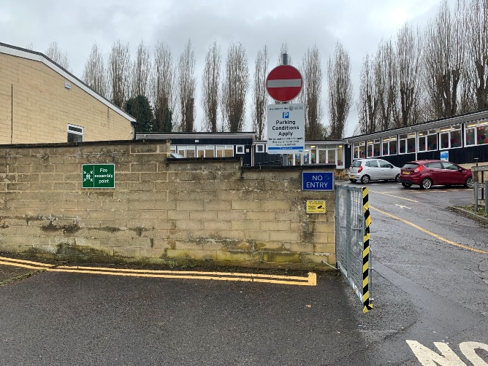

**For attendees coming to the venue:**  
- The address of the building is University of Bath Student Union, Dartmouth Avenue, Bath, BA2 1AS

- We encourage environmentally friendly travel. Dartmouth Avenue is very close to the Sustrans cycle and walking path and there are bike parking facilities on site (one sheltered and one unsheltered).

- If you need to drive, there are some parking spaces. Please go into the main building to get a parking pass for the day from Reception. Otherwise, there is permit-free parking on the local road just outside the building.

- When you arrive, head to the building your event is booked for, if you know it. Otherwise, please go the main Reception.

- In the main building there is a kitchen area, as well as vending machines and toilets.   
- Please ensure you leave spaces clean and clear before you go.

- If you need any help, Reception is in the main building.