The assessor can assign values for the hazard severity (a) and likelihood of occurrence (b) (taking into account the frequency and duration of exposure) on a scale of 1 to 5, then multiply them together to give the rating band:

Hazard Severity (a) |  | Likelihood of Occurrence (b)
1- Trivial | eg discomfort, slight bruising, self-help recovery | 1- Remote | Almost never
2- Minor | eg small cut, abrasion, basic first aid required | 2- Unlikely | Occurs rarely
3- Moderate | eg strain, sprain, incapacitation >3 days | 3- Possible | Could occur, but uncommon
4- Serious | eg fracture, hospitalisation >24hrs, incapacitation >4 days | 4- Likely | Recurrent, but not frequent
5- Fatal | Single or multiple | 5- Very Likely | Occurs frequently
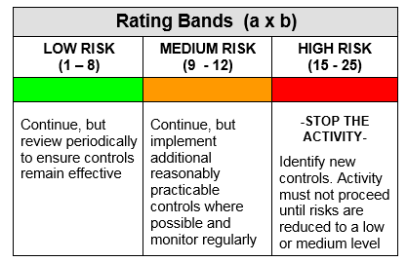
The risk rating (low, medium or high) dictates the level of response required when designing the action plan.
 | Trivial | Minor | Mod. | Serious | Fatal
Remote | 1 | 2 | 3 | 4 | 5
Unlikely | 2 | 4 | 6 | 8 | 10
Possible | 3 | 6 | 9 | 12 | 15
Likely | 4 | 8 | 12 | 16 | 20
Very Likely | 5 | 10 | 15 | 20 | 25

