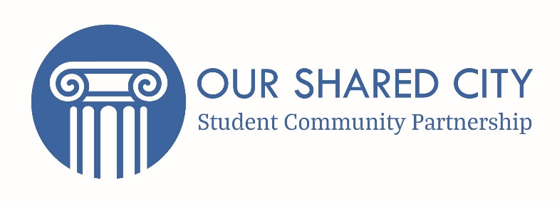

Student Community Partnership
Community Fund Terms and Conditions

Date:
Grant Reference No:

The Student Community Partnership have agreed to support your initiative with a grant of £250.

The conditions under which the grant is offered are as follows:
- The grant is made only for the purpose for which it is intended, as set out in the application and as approved by The Student Community Partnership (SCP) namely towards the cost of the project. Any proposed change of use of the grant money must be discussed with the Community Liaison Co-ordinator who may refer the change of use of the trust grant to the SCP for their further consideration and approval.

- If the grant or any part of it is not used for the agreed purpose, the grant or any balance shall immediately be repaid to the SCP. If this grant is not spent within the 2019-20 Academic Year (unless there are exceptional circumstances) you will be required to return the funds and submit a new application.

- You must provide proof of purchase/receipt for any items purchased with the SCP Community Fund. Any funds given by the SCP that cannot be accounted for with prove of purchase/receipts must be returned.

- The Student Community Partnership has no legal liability or responsibility for any loss, damage or expense whatsoever arising, directly or indirectly from the SCP’s support. We recommend you consider very carefully any Health and Safety issues associated with your project.

- A Grant Monitoring Form on the project and its progress will be forwarded as requested or on completion as appropriate. The report shall include brief details of how these funds were used.

- You must acknowledge the Student Community Partnership support where possible. The ways in which the SCP Community Fund has been spent may be publicised by the SCP, including on the SCP website. Do please take photographs and receive consent for them to be used for publicity. However, before publicity, please email community-liaison@bath.ac.uk for approval. Potential channels of promotion include: Bath Chronicle, Bath Echo, Bath and North East Somerset Council press office, the local councillor of where the project is taking place, Facebook, Twitter, Students’ Unions webpages and specific tags on social media must include the SCP.

I accept the offer of the grant of £250 from the Student Community Partnership, subject to the above conditions

Signature___________________________________ Date_____________________________

Name (Capital Letters) ________________________________________________

Please complete your bank account details for payment purposes:

Name
Student Number
Bank Name and Address
Sort Code
Account Number

Please return one signed copy of this form to Kalyn Mallard- Community Liaison Co-ordinator, Student Community Partnership, Norwood House 4.14, University of Bath, Bath BA2 7AY, United Kingdom

