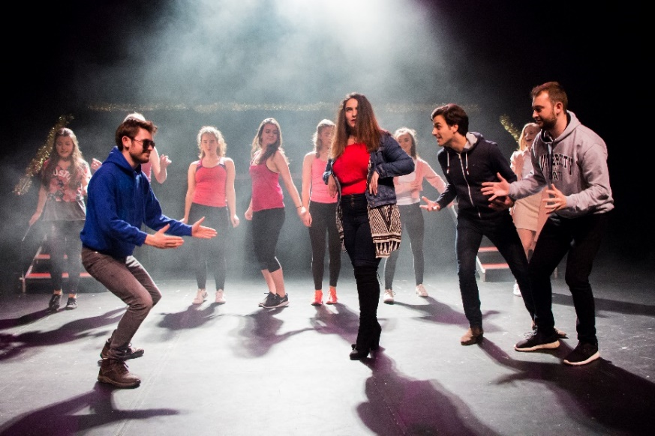
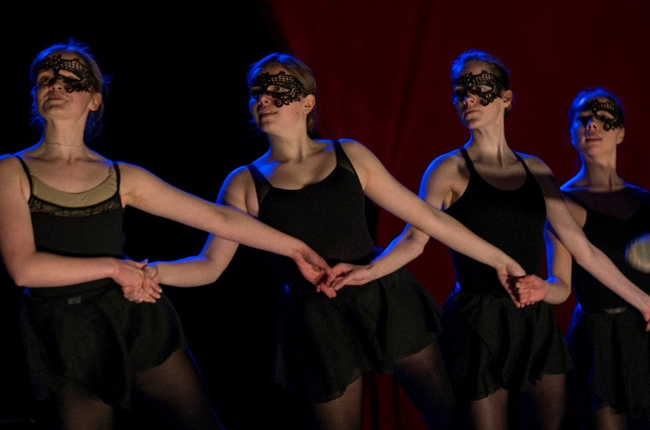
Contents
Societies and The Edge
2020 Semester 1 – Including COVID-19 Procedures

Our Spaces 3
COVID-19 procedures 5
Preparing for your Activity 7
Risk Assessments 9
Rehearsal Bookings 12
Access at The Edge 13
General Info 15
Key Contacts 16

Our Spaces

The Edge Theatre
Our Arts Theatre is suitable for rehearsals and performances across music, theatre and dance, with 204 seats. It’s also an ideal space for symposia, conferences and talks. There are 2 dressing rooms and a green room located off stage left, with access also available from the foyer. Both dressing rooms have two lit mirrors, audio show relay from stage and calls from the tech box. Toilets and showers, including disabled, are accessed off the green room.
*COVID-19*
The current capacity for the theatre space is now 31 people maximum.
The current capacity of the dressing rooms is 1 person maximum. This should not be used unless permission is granted by SU staff.
Performance space:
Width of stage – 11.8m
Depth of Stage – 11m
Height to bottom of rig – 5.9m

Weston Studio
The Weston Studio hosts small-scale performances of professional and student work as well as daily workshops and rehearsals. The space is technically equipped to show intimate experimental, contemporary and interdisciplinary work alongside a host of other events from talks to conferences. A lockable dressing room, suitable for 4-5 people, is available off stage right. The studio has retractable seating banks on one side of the performance space. The seating banks have 72 seats.
*COVID-19*
The current capacity for this space is 20 people maximum.
The current capacity of the dressing room is 1 person maximum. This should not be used unless permission is granted by SU staff.
Performance space:
Total Size of room - 14m x 11.8m
Width of stage – 11.8m
Depth of Stage - 8.5m
Height to bottom of rig – 4.5m

Other Spaces
We also have the Ensemble Room, Dance Studio, Fine Art Studio, Music Studio, Digital Studio, Choral Practice Room, and smaller practice rooms available.
COVID-19 capacities for all rooms:
Ensemble Room | 16
Dance Studio | 14
Fine Art Studio | 14
Digital Studio | 6
Music Studio | 1
Choral Practice Room | 1
Piano Practice Rooms (x3) | 1

All room capacities will be indicated on the door to the room. If you have questions about the building or facilities at The Edge, especially during the pandemic, please contact the SU Arts team.

COVID-19 procedures

Room Use
The Edge building has a one-way flow system throughout most of the building. Please follow all signage present in the building when coming into the spaces.
Each room has a specific COVID-19 risk assessment (RA) and normal operating procedure (NOP) document which you must follow. These documents will be sent to all committees, and will be listed on the SU website. Each room’s NOP will also be posted on the door to the room and will be sent to you when you book rooms via our online system.
For all rooms you will need to adhere to the following procedures:
- Do not exceed room capacity.
- Do not attend any sessions in this room if anyone in your household has any symptoms (high temperature, new continuous dry cough, loss or change to sense of taste or smell), in which case you should self-isolate according to government guidelines.
- You must have registered attendance at any session as part of the SU Test and Trace procedure.
- Always observe 2m social distancing within the room, ensuring doors and walkways are clear.
- Do not obscure any source of ventilation and leave vents open where possible
- After your activity has finished, please leave all windows and vents open. This is to ensure maximum ventilation between room use.
- You must clean any equipment, furniture or instruments in the room before and after use with cleaning products provided.
- Cupboards should only be accessed when necessary, and by the sole person to use the items inside. That person should also be the only person to return items to the cupboard.
- You must wear face coverings in our public, indoor spaces and when moving between indoor spaces.

Test and Trace
To comply with COVID legislation you must ensure that you collect the name and contact number of everyone attending your activity (including organisers and staff). This is a requirement in law and must happen for every event, activity and/or rehearsal that you run.
The easiest way to do this is to create a signup list via thesubath.com admin tools. Instructions detailing how to do this can be found on the SU Test and Trace procedure document.
Only in exceptional circumstances, for example the on-line sign-up process is unavailable, should hard copies be used. In this case please record the following details of all those present and send the information to susocieties@bath.ac.uk.
- Name / library card number
- Contact phone number
Within the email please confirm the session details too (group name, venue, start/finish time).
You may also be required to sign in via an additional Test & Trace app when using certain venues too.
All participants must share this information, or they will not be able to attend the event or activity. This information will be stored for 21 days after the activity has taken place.

Group Sizes
When using a room, you must always be within room capacity. You must also follow current government guidance regarding group sizes when meeting.
While we know that this may change, the current government guidance (which can be found in section 3.18 here) regarding whether amateur arts groups can meet is as follows:
“It is against the law to gather in groups of more than 6, where people are from different households or support bubbles. Some activities - such as those organised for under-18s - are exempt. In a COVID-19 Secure venue or public outdoor place, non-professional performing arts activity, including choirs, orchestras or drama groups can continue to rehearse or perform together where this is planned activity in line with the performing arts guidance and if they can do so in a way that ensures that there is no interaction between groups of more than 6 at any time.
If an amateur group is not able to ensure that no mingling takes place between these sub-groups of no more than 6 (including when arriving at or leaving activity or in any breaks or socialising) then such non-professional activity should not take place.”
In following this legislation, separate groups can be counted if they remain >2m apart. 2m social distancing must however be followed even within a group of 6, so this should not create much additional concern to societies when planning their activities.

Preparing for your Activity
STEP 1: SPEAK TO US ABOUT YOUR ACTIVITY (ASAP)
As we need to ensure that any activity is planned in a way which remains COVID-safe, we will be meeting with every society before their bookings commence so that we can answer any questions and make sure that you are aware of all the procedures to follow. Please get in touch with us as soon as you start to plan your semester’s activity.
As every society is different, we would like to make sure we work with you to make sure that you are adapting your activity for current COVID-19 procedures and are being realistic in your planning and expectations.
Please be aware that due to lowered room capacities, no audiences will be able to attend shows. You may however wish to film or livestream events for people to enjoy digitally.
SU Arts Team | To be confirmed
SU Arts Development Manager | Alex Clarke ahlc21@bath.ac.uk

STEP 2: ORGANISING TECH FOR YOUR ACTIVITY (ASAP)
Should you require technical services, decide what the tech requirements are for your activity and contact Backstage Technical Services to book www.bts-crew.com/book-us.
Backstage are an SU society and help create and support most of the student shows at The Edge. Once you book them they will work with you regarding all technical elements of your activity. BTS will communicate with The SU on technical issues if required and will complete a technical risk assessment. BTS will generally charge a production charge. We recommend contacting them at least 4 weeks in advance of your planned activity.
As BTS is run by student volunteers, they may be unable to support your show. If this is the case, please contact Claire Worrall (cw887@bath.ac.uk) to discuss potential alternatives.
If your activity is a simple lecture-style set up, you may want to consider getting technical support from AV, although they can only provide for basic sound and video. You can request this via AV’s online portal here.
Backstage Technical Services | Backstage committee info@bts-crew.com
SU Technical Co-ordinator | Claire Worrall cw887@bath.ac.uk
STEP 3: COMPLETE AN EVENT PLANNER (at least 3 weeks before your event)
Complete the online Event Planner which can be found here: www.thesubath.com/new-event. If you have not completed this by the deadline your event will not be able to go ahead.
If you are running an event that is separate from your usual weekly activity, the Event Planner will help you to think about all the different aspects of your event including finances, contracts, venue/space booking and risk assessments. It also gives the SU more information on what you are doing which allows us to support you and will help you to ensure you put on the best event for your members.
If you need any assistance, please do not hesitate to contact the SU Activities Team.

STEP 4: WRITE AND SEND YOUR RISK ASSESSMENT (at least 1 week before your event)
We realise that risk assessments may seem complicated at first, especially due to the addition of additional COVID-19 risk assessments. The section on risk assessments below gives additional guidance on what risk assessments you need to consider, and you can also find more information on the SU Health and Safety Page.
Complete the risk assessment (template forms can be found here) and send to susocieties@bath.ac.uk, as well as both Claire Worrall and the Activities Administrator (when in post). It’s usually a good idea to ensure we receive this early, as we will have time to review it and make changes if needed.
If you need additional guidance, please contact susocieties@bath.ac.uk or Claire Worrall
What do you need to include? | - Any performance related risks such as acrobatics, prop weapons, water, dance, falling from a height, glass etc.  - All COVID-19 measures you are taking  - Any technical risks will be completed in a separate risk assessment by BTS (in collaboration with your society) for events they are supporting

Risk Assessments

Risk Assessment Training
You can now access the Health and Safety Module via the SU Training Hub . You will be redirected to the Health and Safety page where you will find an online module to complete followed by a quiz. This training is compulsory for all Student Leaders who will be involved in running a student group, organising or leading an event or trip.
In this module you will learn:
- The key factors of health and safety
- Principles of duty of care and your individual responsibility
- Importance of a risk assessment
- How to complete a risk assessment- Including COVID considerations
- How to identify potential risks of an activity
- Where to report an accident
Further modules are being designed so it would be greatly appreciated if upon completion of the module you can complete the feedback questionnaire to ensure all modules designed meet your needs.
Further information on risk assessments, including a form template, can be found on the SU Health and Safety page

SU COVID-19 risk assessments
The SU has written several risk assessments to guide society activities throughout the COVID-19 pandemic. These are:
SU General COVID-19 Groups Risk Assessment
A copy of the SU COVID-19 Groups Risk Assessment can be found on the SU Health and Safety page.
This is intended to provide guidance on general COVID-19 procedures to be followed by all SU Groups. Please take information from this and update your society risk assessment with any applicable points for making sure your standard group activities are ran safely. Once you've updated your standard society risk assessment, please send that version over to us.
This RA is intended to be very general and cover a broad range of activities but may not cover all the specifics of what your group does. You should think about all the activities your group is likely to do, and make sure that you write additional COVID-19 risk assessment for this. If you feel any of your activities need to be COVID risk assessed but can't find that information in the general RA, get in touch with us and we can help you work on any points needed.
Edge Room Risk Assessments
There is a risk assessment in place for every room in the Edge, which you should be adhering to when using that room. These risk assessments will be sent to society committees.
These risk assessments will cover the basic rules for room use, but will not include assessment for any specific society activities within that space, so you should include this in you risk assessment.
Stores and Equipment Risk Assessment
A copy of the SU COVID-19 Stores and Equipment RA can be found on the SU Health and Safety page.
As many societies have equipment which they use and store, we have also produced a general RA which covers:
- Accessing stores
- COVID-19 guidance for manual handling
- Safe use of equipment
- Cleaning procedures for equipment
As with the SU groups risk assessment, this is intended to provide guidance on the general procedures societies should take regarding storage and equipment. You should take information from this to include in your society risk assessment and add in any specific information on how you will manage your society’s equipment.

What Risk Assessments you need to write
General Society Risk Assessment
Every society should have a risk assessment in place covering all their regular activities throughout the year. You should be updating your society’s general risk assessment on a yearly basis.
You will need to update your society risk assessment for this year. You will also need to make sure that COVID-19 measures are included in your general risk assessment this year. Please use the SU risk assessments listed above as a basis for this, but make sure that you have thought specifically about everything that your society does on a regular basis and how you will incorporate COVID-19 precautions into these activities.
When you have completed this, please send it to and send to susocieties@bath.ac.uk, as well as both Claire Worrall and the Activities Administrator (when in post). You will not be able to access any of the Edge spaces until this has been approved.
Specific Risk Assessments
If you are doing something out of the norm for your society, like a show or event, you will need to consider any additional risks to those in your standard RA. This means that for any shows or events you will need to produce an additional risk assessment covering these risks.
Your evet risk assessment is due at least one week before your event, although it’s a good idea to send it in early so that there is plenty of time to make sure this is adequate. If you need any additional support for event risk assessments, contact Claire Worrall (cw887@bath.ac.uk)

Example Risk Assessment
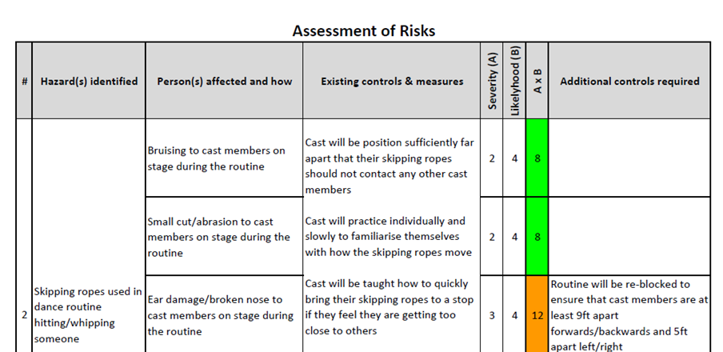
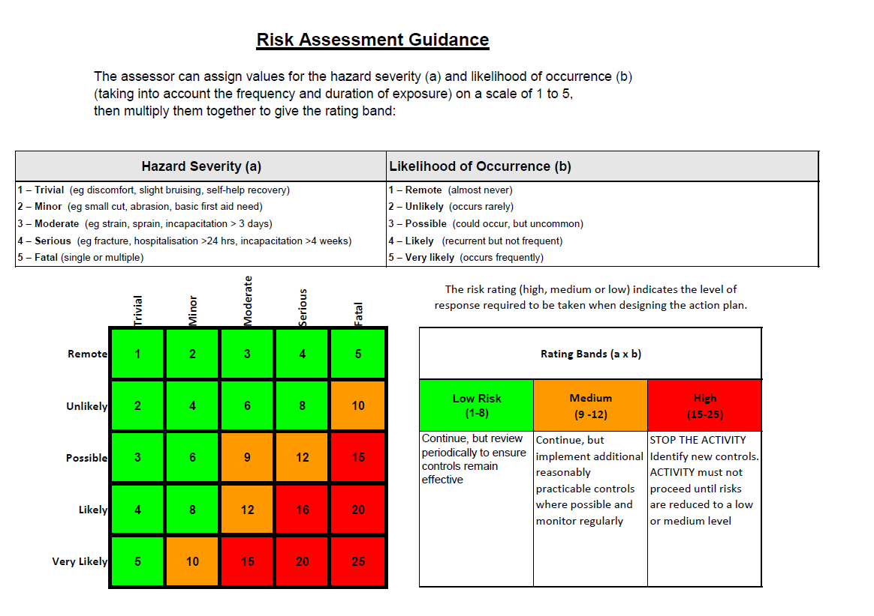
Rehearsal Bookings
PLEASE NOTE NO REHEARSAL BOOKINGS WILL BE ALLOWED TO GO AHEAD UNTIL YOUR SOCIETY HAS COMPLETED A SUITABLE COVID-19 RISK ASSESSMENT FOR YOUR ACTIVITIES.

Regular Rehearsals
- All regular rehearsals and shows are planned a year in advance.
- In March, The SU will contact societies to ask for their regular rehearsal and show requests for the upcoming year.
- The SU collate these requests, assess availability and book in available space using our room booking system.
- If you have any queries about regular rehearsals at The Edge, please contact Alex Clarke on ahlc21@bath.ac.uk.

Additional Rehearsals
If you want to book extra rehearsal time, we have an online room-booking portal called Agora. You can sign up as a society to access the Student Society Bookings and make extra bookings alongside your regular bookings. These will then be sent to Arts Team staff for approval.
Please note:
- You are can book up to 4 hours of additional rehearsal time per week.
- Only the two nominated committee members can book this. Bookings requests from other members of the society will not be processed. If the society has sub-groups, the manager/leader of these individual groups can also make ad hoc bookings.

Individual Practice Room Bookings
Individuals will be unable to book practice rooms for the moment while we ensure that our current COVID-19 procedures are adequate to allow this. We hope to have this up and running sometime shortly.

Access at The Edge
We endeavour to make The Edge as open and accessible as possible for all students who use the space.
Bookable Hours
Weekdays 9am – 9pm
Weekends 10am – 6pm

Please note that due to added COVID-19 cleaning procedures limited time slots will be available to accommodate the need for a cleaning period between bookings.
Two nominated members of committee will be given library card access to booked rooms in the Edge, who will be able to let societies in for their bookings. Please be mindful to only enter at booked times and be respectful of the space, or access may be revoked. Be aware this system may change as we hope to link library card access automatically to our booking system in the near future.

Things you need to know about bookings:
- Room use operating procedures will be posted on the door to the room and will be emailed to you if you book online.
- If you have multiple rooms booked for your society, please be aware that procedures may be different from room to room. Please ensure you understand what is required of you in each space.
- You are responsible for ensuring any members of your group participating in activity at the Edge adhere to all procedures at all times. Any procedures that are not followed, particularly concerning Covid health and safety, may result in society room access being revoked.

Accessing lockers:
If you have an instrument or any equipment in a locker in a different room from the one your activity is taking place in, please follow these guidelines.
- Discuss as a committee which lockers may need accessing ahead of specific activities.
- Committee to provide Arts Team with locker access requirements.
- Arts Team to propose times to access lockers. All students must adhere to these timings once agreed.
You must sanitise or wash your hands before and after accessing any lockers or cupboards.

TRAKKA Cabinet
- The TRAKKA cabinet is located at the bottom of the stairs and is used frequently by societies for access to; cupboards, costume store and instrument store.
- If a member of your committee requires access to this cabinet, please email Claire Worrall on cw887@bath.ac.uk and she will make arrangements.
- If you have lost a key or are struggling to gain access to the cabinet speak to Claire Worrall.

General Info
Here you will find useful information about The Edge, which you might like to share with your members.

Lockers
- Lockers can be found in the Ensemble Room, AMP Room, Digital Art Studio, Music Studio and on Level 3 of the Edge where the Dance Studio is located.
- If you have an instrument or a bag you need to store, you might like to consider hiring one of these lockers, which come in a variety of sizes.
- We only have a limited amount of storage so might not be able to accommodate your request.
Ensemble Room | - Instruments of varying sizes for individual use  - If you are a member of ChaOS, you will be prioritised for storage in this space
AMP Room | - Instrument storage of varying sizes  - As this space is managed by MusicSoc, for convenience these lockers will be exclusively for their members
Music Studio | - One tall cupboard for shared large instrument use (Cello/Viola)
Digital Art Studio | - Two tall cupboards for shared large instrument use (Cello/Viola)
Level 3 | - Lockers that are suitable for dancers

You will need to sign an agreement and possibly pay a small deposit.
You can enquire about lockers by contacting Alex Clarke on ahlc21@bath.ac.uk.

Instruments
We also have a selection of instruments that can hire out to students for short or long term use. These are mainly orchestral instruments, but we have a few others. For more information contact Alex Clarke.

Key Dates
If your society are looking to rehearse during the holiday period, please contact Alex Clarke on ahlc21@bath.ac.uk to arrange a suitable time. Please note, it will not always be possible to accommodate rehearsal requests outside of term time due to other activity happening at The Edge.
The Edge will be closed on the following dates:
25th December – 1st January 2021 | Christmas & New Year
2nd April 2021 | Good Friday
5th April, 2021 | Easter Monday
3rd May, 2021 | Early May Bank Holiday (May Day)
31st May, 2021 | Spring Bank Holiday
30th August, 2021 | August Bank Holiday

Key Contacts
CONTACT LIST
Alex Clarke | Arts Development Manager | ahlc21@bath.ac.uk | - Event schedules  - Show/event queries  - General queries  - Additional rehearsal bookings, including weekends  - Arts Development Fund  - Instrument Loans  - Locker hire  - Tuition & classes
In recruitment | Social and Recreational Arts Coordinator
In recruitment | Activities Administrator
Claire Worrall | Lead Technician | cw887@bath.ac.uk | - Tech hire queries  - Risk Assessments  - Booking a Duty Technician  - Technical guidance and support
Carmela Lear | Societies Coordinator | cl291@bath.ac.uk | - Event planner queries or problems  - Setting up online products  - Retrieving results for online elections  - Booking coaches  - Setting membership prices  - All administration duties
Lucy Farrington | Activities Administrator (Societies) | lef35@bath.ac.uk

