# Sport Webpage Layout

In order to ensure our pages offer students the quickest and easiest way to find information about our clubs, we have put together a guide for the sports homepages to follow.

Main headings

* What We Do
* What We Offer
* Come and Meet Us
* Our Committee

Each of these headings should be set to ‘Heading 2’. You can do this in the web editor by clicking the ‘Normal’ button and selecting ‘Heading 2’ from the dropdown:

Under the heading **come and see us**, we would like you to include a contact name and info, along with a session that new members can turn up too throughout the academic year.

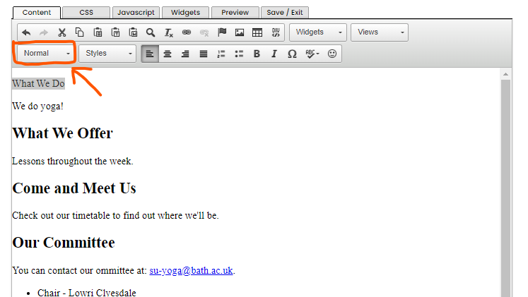

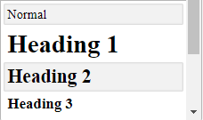

Paragraphs between the headings should be selected as ‘Normal’.

The ‘Our Committee’ section should list your committee in bullet points as follows:

You can contact our committee at: [su-yoga@bath.ac.uk](mailto:su-yoga@bath.ac.uk).

* Chair - Lowri Clyesdale
* Treasurer -
* Secretary -

Again, the text should be selected as ‘Normal’. You can use the bullet point button to create the list:

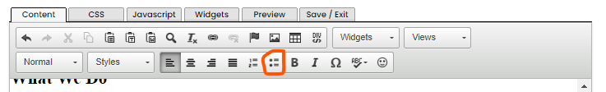

Homepage Banner

To add your homepage banner, select Admin Tools from the Account button:

Please Note:

Please do not add in extra sections/images/styling to the page.

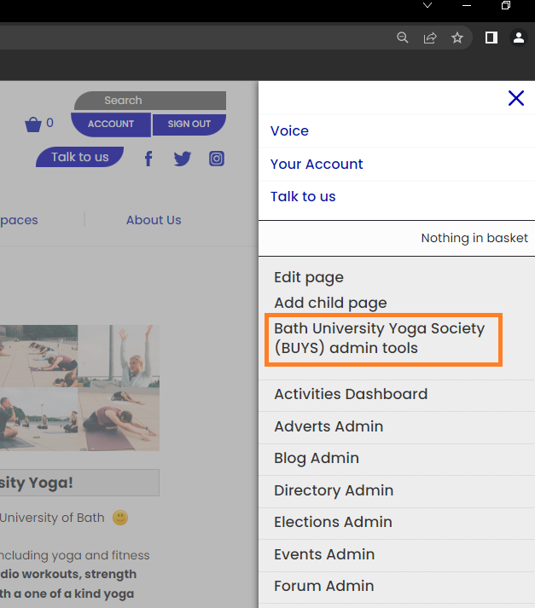

Then select ‘Edit Details’:

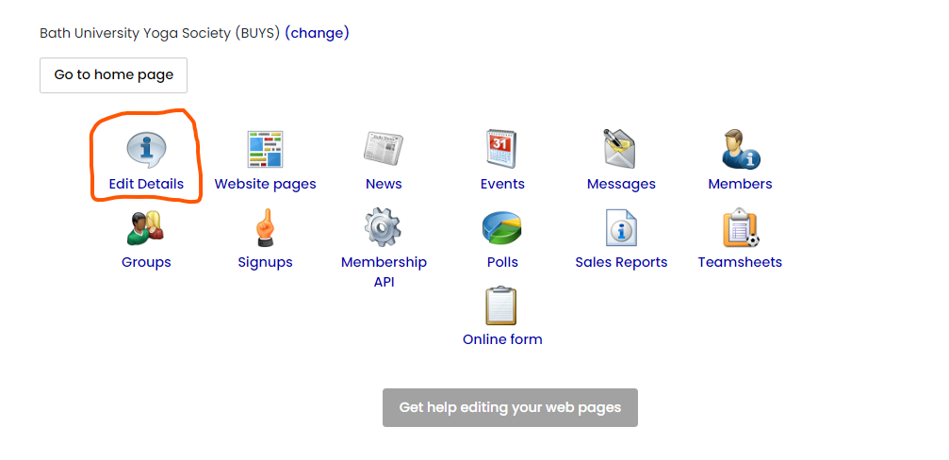

Then in the last box on the page, add in your banner by using the image button (highlighted). Then click ‘Save’.

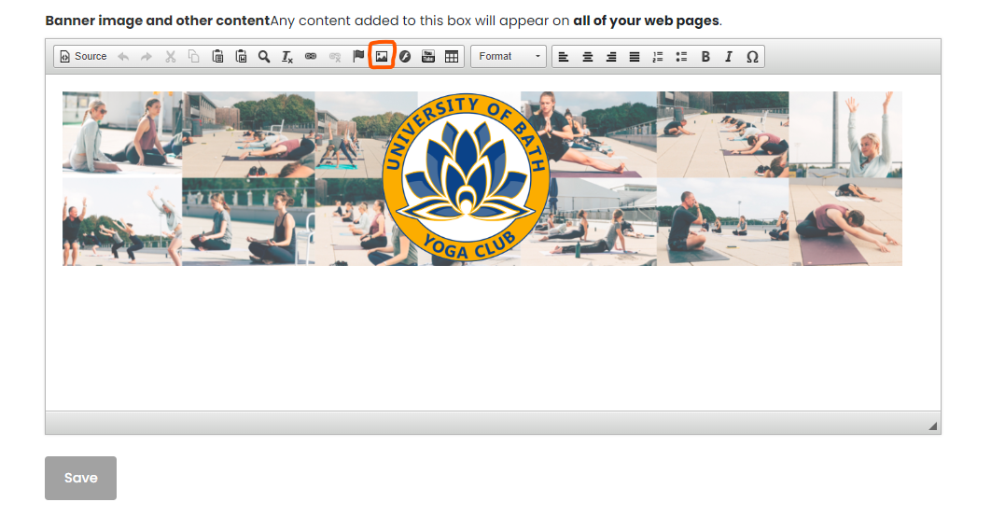

**Child Pages – These are pages that are listed down the left-hand side, of which you can add by clicking account and add child page**

You can have as many of these as you like, but we require you to have a child page for each of the below:

* Training Times – **Must state days/time/ability group and location of the sessions**
* Socials
* Gallery
* Trials and Tasters – This can be a simple sentence directing them to the [what’s on page](https://www.thesubath.com/whats-on/) as this is where you should be listing them too
* Online Products – This is where your online products go once processed by SU Sport Staff
* Competitions/Events - (only if your club competes)
* Club Documents – Risk Assessments and Club Development Plans need to be included here

**Social Media Links**

If you don’t use certain ones, then please make sure they are not visible on your webpage. We only want to be display current and up to date information

**THANK YOU, and we can’t wait to see the new look of your club’s page! Make sure to always keep it up to date**