

Minutes
________________________________________________________________________________________________
Meeting: | SU Sport Exec
Place: | CB 3.16
Date and Time: | 4th Dec 12:15
________________________________________________________________________________________________

Present | Sport Officer | Angus Gueterbock
 | Sport Exec - Chair | Emily Mcmanus
 | Sport Exec - Treasurer | Anna Fertig
 | Sport Exec - Treasurer | Thomas Bristow
 | Sport Exec - Performance Sport Officer | Emily Dunn
 | Sport Exec - Recreational Coordinator | Charlie Williams
 | Sport Exec - Media and Marketing Officer | Jenni Hargreaves
 | Sport Exec - Media and Marketing Officer | Isaac Chase
 | Sport Exec - Welfare and Inclusivity Officer | Max Moir
Apologies | Sport Exec - Events Coordinator | Bhoomi Singh Jadon
 | Sport Exec - Media and Marketing Officer | Annabelle Walter
Did not attend
In attendance | Stacey Bromley | Sport Admin

 |  | Action
1 | Apologies for absence – As above
2 | Exec Project Updates (EM) –  AG / EM – Thanks for uploading your project updates, we will now discuss these  EM- Grassroots Project  Progress  Have met with SU Staff (Jo Dixon, Helen Webb and Suzanne Jacob):  - Once developed will make use of mandatory donation minimum. Will wait for release before advertising.  - Obtain branding pack to use: Obtained already from grassboots  Challenges/Concerns  Need phone number to change contact details  - Ask Stacey/SU web to generate a teams number  Next Steps  Check example sales statement with those in SU meeting  - Would finance be able to process it?  Advertising launch if viable to go ahead  - Media Sport Exec to be involved  Investigate the long-term upkeep required once launched  In regular contact with company  - Locking to change over contact details on account  - Have received example sales statement  MM – Welfare  A short overview of my plans  - Set up welfare training for incoming 25/26 committee members  - Establish groundwork within clubs to better promote welfare  What areas are of interest to me?  - Committee handovers, better welfare systems intra-clubs, advertising for inclusivity schemes  Actions and goals to achieve this plan  - Set up conversations and plans with NeverOK to create more training for committee members entering the role  - Sending out a form to gage current state of socials, e.g. non-drinking/inclusive in other ways  - Termly forms on success of the welfare officer within each club, feedback to be passed onto next years  - Possible anonymous concern form to encourage sharing of information if contacting staff feels too serious – talk to web team about it (staff and or welfare officer to read and process results)  ED- Performance  Progress  Met with Sam Smith to discuss my project.  Approved of it! At the next exec meeting suggested maybe some case studies to keep track of the impact of performance benefits. Started the data base detailing performance benefits and performance vs non-performance. Discussed how the aims of the sport club change with performance vs non.  Started talking to rowing about how maybe the S + C isn’t working  Challenges/Concerns  Which sports are performance?  Whether some clubs are still running  Rugby what’s the difference  Snow sports?  Next Steps  Talking to other clubs about how their benefits are working for them.  Maybe starting talks about introducing benefits for other clubs.  Group Discussion about this project:  AG- Speak to Sarah Collins – to help identify the performance sports  EM- Maybe look at which teams in a club are getting support  CW – Recreational  Progress  Have been in touch with dodgeball about setting up a dodgeball “world cup” with faith and cultural groups, should be going ahead in February. Have mostly been focussed on Daily Mile (and coursework) this month so not as much progress as I would’ve liked.  Challenges/Concerns  I have heard from the Activities Exec however not with the info/ insight I was hoping for so will need to follow up.  Next Steps  Follow up with activities exec, continue to support dodgeball and attend their event in February.  Group Discussion about this project:  AG- We are going to launch another bigger and better Daily Mile for Semester 2. This will require lots more marketing to happen  EM- Have we found out about Mountaineering with regards to the daily mile.  ED- Submission process for Daily Mile was not good, so put me off  TB- Finance  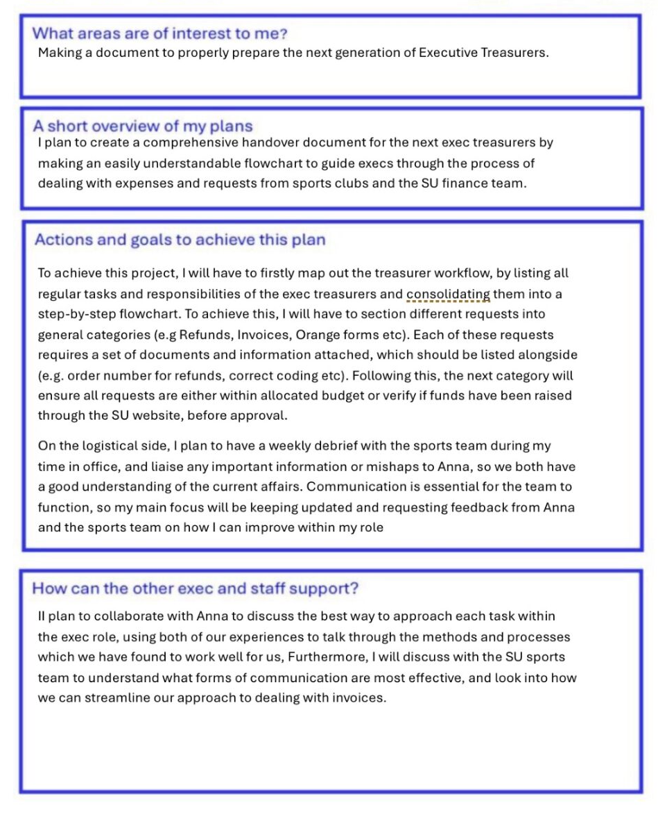  Group Discussion about this project:  AF- In person mandatory training is really needed, as online just isn’t working and can be skipped through without taking the info in  Meeting up with next year’s exec treasurers  SB- The SU are looking into a new finance system, so the handover doc may not be relevant come next year if processes have been changed | All Exec to keep up with their  project work  CW to get in touch with mountaineering club  AG – To confirm when new finance system will start
3 | Media Content/Values and collaborating with clubs (Open discussion) (EM)  EM- Looking at media work going forward, now we have 3 in post.  Fixture posts – When should these be posted (ideally mon or Tues)  AG- What should insta be used for?  IC- Look at creating a BUCS result post for a Thursday (speak to Sam Smith for info)  JH – Want more rec clubs to get involved. Has tried emailing them to say media exec exists but getting no response back. It’s just the same big clubs getting in touch | Media Exec Team - look at creating a media strategy. Speak to Joe Rumford (marketing) for any help  Media Exec Team – Wednesday Fixture Posts to go up earlier in week
4 | Rewards for well-managed Clubs (Open discussion) (EM)  AG- Over the past few years, it has become noticeable that clubs are not following correct SU processes (finance form approvals, event planners, welcome socials etc), even though there is training available.  How do we get clubs to follow these processes? Should it be negative reinforcements or rewards. Not money though.  Ideas provided:  ED - Blues award / SU Awards / Shout outs on a media post  EM & AF – House points / Early access to major tickets (snowball/varsity etc)  AG- Naming and shaming | All to feedback any ideas to Angus
5 | Club Committee Structure (To note) (EM)  AG- Committees capped at 12, but some clubs are wanting more. I personally don’t think they do need more than 12. Convo starter – reviewing what positions should be on committee?  Points raised by group:  All clubs work differently  Look at unofficial roles / Leadership group to help with workloads | Feedback anymore idea to Angus
6 | Any other business  Welcome to Isaac the new media sec – Quick introductions to the team  JH- Can clubs input into these exec meetings?  Exec Team wanting an update on exec tops | EM – investigate what clubs want to be discussed in these execs meetings & chase exec tops + sort out 2 new ones
7 | Notifications of next meeting: Feb TBC
8

