

Minutes
________________________________________________________________________________________________
Meeting: | SU Sport Exec
Place: | CB 5.7
Date and Time: | 6th Nov 12.15
________________________________________________________________________________________________

Present | Sport Officer | Angus Gueterbock
 | Sport Exec - Chair | Emily Mcmanus
 | Sport Exec - Treasurer | Anna Fertig
 | Sport Exec - Performance Sport Officer | Emily Dunn
 | Sport Exec - Recreational Coordinator | Charlie Williams
 | Sport Exec - Volunteer Recognition Coordinator
 | Sport Exec - Welfare and Inclusivity Officer | Max Moir
Apologies | Sport Exec - Treasurer | Thomas Bristow
 | Sport Exec - Media and Marketing Officer | Jenni Hargreaves
 | Sport Exec - Events Coordinator | Bhoomi Singh Jadon
Did not attend | Sport Exec - Media and Marketing Officer | Sixtine Maury
In attendance | Stacey Bromley | Activities Admin
 | Jo Dixon | Sport Manager

 |  | Action
1 | Apologies for absence – As above
2 | Project Proposals (EM)  Exec members were asked during the previous meeting to write and upload their project proposal to the exec strategy in Teams. Today Exec ran through their projects and discussions were had within the group around it  CW – Recreational Coordinator Project  Ensuring the Bath Active Scheme is visible and well utilised by members of the university, whether that be an individual or a society/ sports team that wants to get involved.  Encourage and enable societies to collab with sports teams, continue to develop and add to the Bath Active offering, ensure the scheme is visible and is seen as open and welcoming to all.  Work with members of the Activities Exec – they are currently talking to different societies about what sports they might want to get involved with. A good starting point here is Faith and Cultural societies, if they have sports that are played in their culture then we can help set up a collab with that sport or try to get it added to the Bath Active scheme to allow them to enjoy it in an uncompetitive environment. As well as this we can talk to diversity and support groups to see what they might be interested in eg. Feminism and Gender Equality collab with kickboxing to run a self-defence session. Having met with Activities Officer I should soon be in touch with the appropriate Activities Exec members to start organising this.  Reach out to sports that can be easily accessed (minimal kit, easy to pick up) to discuss whether they would be interested in joining the Bath Active program. Either through email, Teams call or meet in person. As well as now, start setting up ideas for Semester 2 when more “summer” sports will start up.  I (along with the help of Media) hope to photograph/ video some current Bath Active sessions as well as any collabs we can setup (or get societies to send us their photos from the collab). Also get some testimonials written for collabs and get them seen on the Instagram and by club email to encourage more clubs and societies to give it a go.  AG- Do we need a separate Instagram for Bath Active, to allow for more rec content as the current one is more Bucs fixtures. Would it be worth it to get more students involved in rec sport?  CW – Think that would be a good idea  SB- Would need to be discussed with media exec and the marketing team if it goes ahead  AF- The clubs run their own Instagram and are good at promoting their own rec events. Rather than another Instagram why not push the what’s on page  EM – What about posting a Bath Active post on the current Instagram instead  All execs were happy for CW to carry on with his proposed project  ED- Performance Sports Officer  Difference between performance sports and non-performance sports  Seeing what clubs are doing to fill in some gaps  Seeing what we can do to fill in those gaps as well  Producing a database of performance and non-performance sports, including the benefits each sport enjoys, and the impact it has. Filling in the gaps between those performance and non-performance sports as much as possible. Setting up a plan for the future performance sports officer to continue building on the work I’ve done.  - Detail what benefits each performance sport has (specific to the sport etc), and what impact that has  - Talk to all non-performance sports and find out what they want the most help with/ would benefit the most from  - Increase use of facilities / increased income for the Team Bath facilities.  -Create a list of opportunities that non-performance sports have been given, and list the impact they have had  - Create more opportunities for these clubs, and offer them to more clubs  To ideally end with a large database of performance sports, non-performance sports, the benefits each club has and the impact they have. The incoming performance sport officer can then build on what I have done, further increasing the size and quality of these opportunities  AF- What is Rowing doing in the Performance Gym?  AG- They will be using for S&C, of which is being offered to all clubs, so we need to find out what clubs have it and who doesn’t.  AF - Some clubs have not been contacted back by George Studd when asking about S&C  AG - I can chase on clubs behalf if needed should George not respond after several attempts of contacting him  AF- Who dictates what is a performance sport?  AG/ JD – Sports Dept decide what clubs are performance sports. They look at Bucs and these performance sports can allow for externals to be invited in  Students need to meet a certain standard to be a part of them. If Bucs level is too low, it needs to be looked at being split  Bucs should just be a pathway.  All execs were happy for ED to carry on with her proposed project  MM -Still to write his project proposal up but updated the group with the below  I met with Jo about setting up a mandatory welfare role on committee. So far, I have chased clubs that don’t currently have one about getting one set up. Currently the role can be joined with another committee role, however, should it be its own core role and what would their role be or could it be blended with another role.  I have also worked on both Buddy Schemes. Re-designed and updated the exercise buddy form, of which 25 people have signed up so far.  JD - A lot of clubs are at max committee capacity already. If it wanted to be a core role that would change the groups policy.  Students can access support via the online tools on the SU website, of which we would advise and direct them to use should any welfare issues arise (support and report tool)  As for the buddy schemes could we look to promote the scheme more, especially to 1st years, and even link up with Sarah Williams (community manager) to discuss this further  EM - Chair  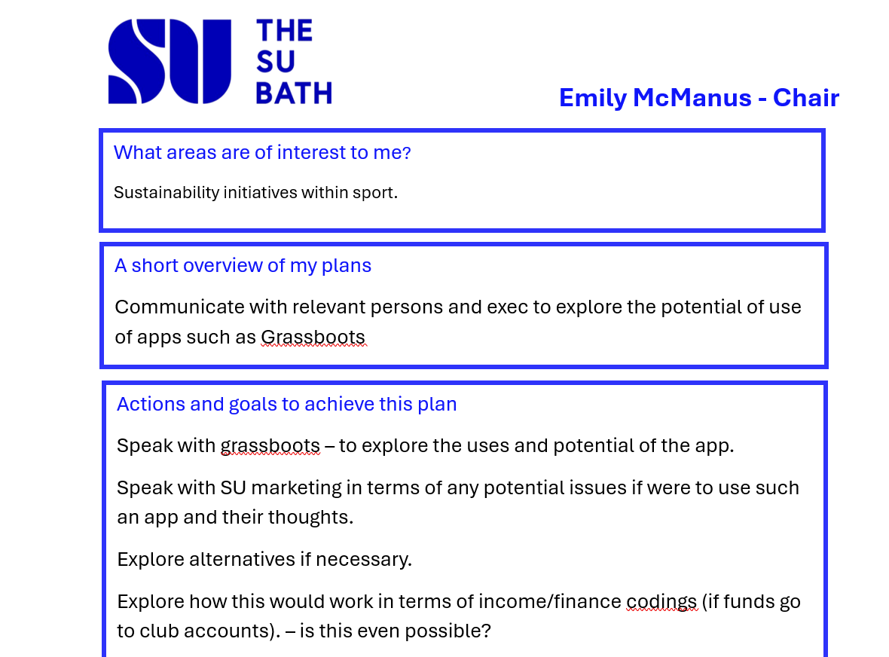  EM- I met with Mark from Grassroots, of which I can share some documents that I have at a later date.  It will be an SU Bath Market place of where Individuals can upload their old sport kit to sale or clubs can sell items  TB & AF – Treasurer  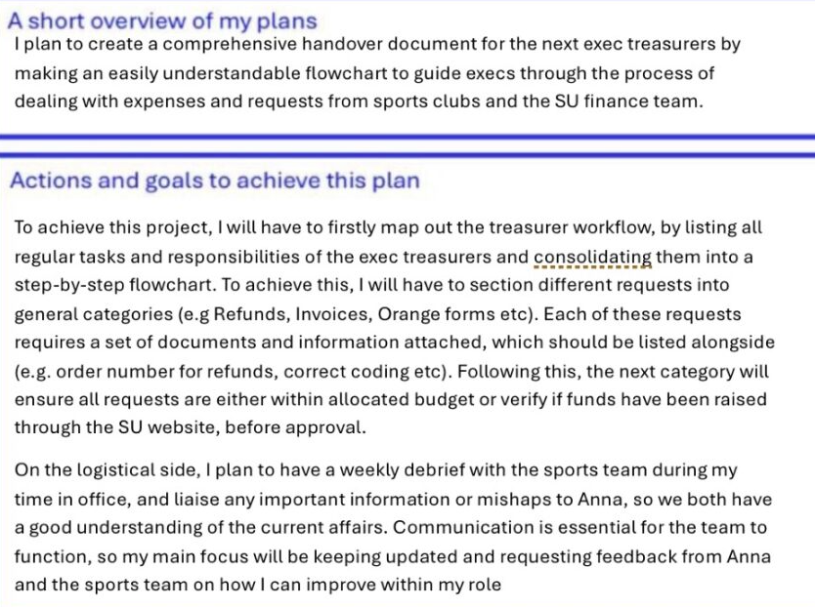  Note - TB was not present at the meeting so the proposal will be discussed at a future meeting | CW & MM  To think about what rec media content do you want?  ED- go out to clubs to see what S&C they have. Use Badminton as case study as they are no longer a performance sport  MM / AG - To look at whether the welfare role should be a core role for all clubs. Would need to be flagged with SU staff and taken to leadership  Speak to Sam Ellis Hunt too  MM – To write up his project proposal  & look to promote the buddy schemes  EM – further discussion with su staff about the grassroot app
3 | Inter Departmental Sport (ED)  ED – I had a course mate ask about IDS (especially football) as no matches have been happening  EM – I spoke to Angus and JO.M who said Football & Rugby have a committee member to look after theirs  AG – I think we need to identify the problems (pitch space etc) and then speak with the clubs and find out how to support them with the offer | ED- Get in touch with Football
4 | Committee On Placement (AG)  AG – I have been receiving some feedback from clubs about committee roles who are on placement - especially those roles that are core.  They are less available and have less insight on what is happening within the club  Should there be a policy to stop placement students being on committee?  Would the same rules apply to the yearly placements and those that are only on a 6 month one?  EM/AF - Sailing and Taekwondo chairs were abroad, so other committee members were picking up the workload. We noticed clubs slowly dying, such as not doing the competitions they have previously attended  AG – So should those Core Role members be based in Bath; however, does this include those that have a bath placement?  EM – I think for non-core roles there should be a tick box included on the manifesto about being on placement, so voters are aware | AG- to look at further
5 | Core Welfare Role (AG)  This was discussed as part of MM proposed project
6 | Sport Skill Development (AG)  Ran out of time to discuss this
7 | Any other business  SB – Jo Mansfield would like to remind you all to sign up for take that photos if you can. 17th – 18th Nov. All info was posted on teams  AG- Sixtine is dropping out of the media role, so we are now looking at 2 positions to fill for that role. Deadline for role is tomorrow 7th Nov. 8 people have applied.  CW- DAILY MILE is launching – everyone to at least sign up and motivate, even if not taking part | All Exec - Exec to vote for who they want by letting Emily & Angus know  Sign up to the daily mile on Strava
8 | Notifications of next meeting: 4th Dec
9
10
11
12

