 |  |  |  |  |  |  |  |  |  |  |  |  |  |  |  | Tree nuts |  |  |  |  |  |  |  |  | Gluten containing cereals
Menu item |  |  |  |  | Milk (dairy) | Egg | Fish | ustacean | Mustard | Celery | Mollusc | Sesame | Lupin | Peanut | Soy | Almond | Brazil nut | Cashew | Hazelnut | Macadamia | Pecan | Pine nut | Pistachio | Walnut | Wheat | Gluten | Barley | Oats | Rye | Sulphites
 |  |  |  |  |  | 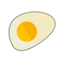 |  |  |  |  | 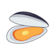 |  | 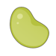 | 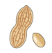 |  | 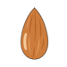 | 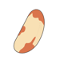 |  | 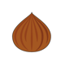 |  | 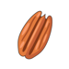 |  | 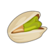 |  | 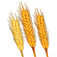 |  | 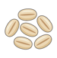 | 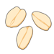 | 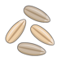
Coffee Beans
Chocolate powder
Chai Latte (Vanilla)
Chai Latte (Spiced)
Matcha Powder
Vanilla Syrup
Caramel Syrup
Hazelnut Syrup |  |  |  |  |  |  |  |  |  |  |  |  |  |  |  |  |  |  | Y
SF Hazelnut Syrup |  |  |  |  |  |  |  |  |  |  |  |  |  |  |  |  |  |  | Y
SF Vanilla Syrup
SF Caramel Syrup
Semi Skimmed Milk |  |  |  |  | Y
Coconut Milk |  |  |  |  |  |  |  |  |  |  |  |  |  |  | Y | M | M | M | M | M | M |  | M | M
Oat Milk |  |  |  |  |  |  |  |  |  |  |  |  |  |  |  |  |  |  |  |  |  |  |  |  | M | M | M | Y | M
Soya Milk |  |  |  |  |  |  |  |  |  |  |  |  |  |  | Y
Mayo
Basil,
Ketchup

