BathStudent.com admin guide
V3.0 16/03/2017
Email any questions to suweb@bath.ac.uk

Contents
How to Log In 2
Exec Committee Admin Tools 2
A: Updating logo and social media details 3
B: Creating and managing Event listings (and tickets) 3
How to set up and sell tickets for your event 3
C: Send messages on behalf of your club/soc 4
Why? 4
Using a template 4
Reusing an old email 4
Editing a message 4
D: Signups 5
E: Teamsheets 5
F: Sales Reports 6
G: Web Page Editing 6
Editing your home page 6
Editing all other pages 6
External websites 9
Is there anything we’ve missed? 9

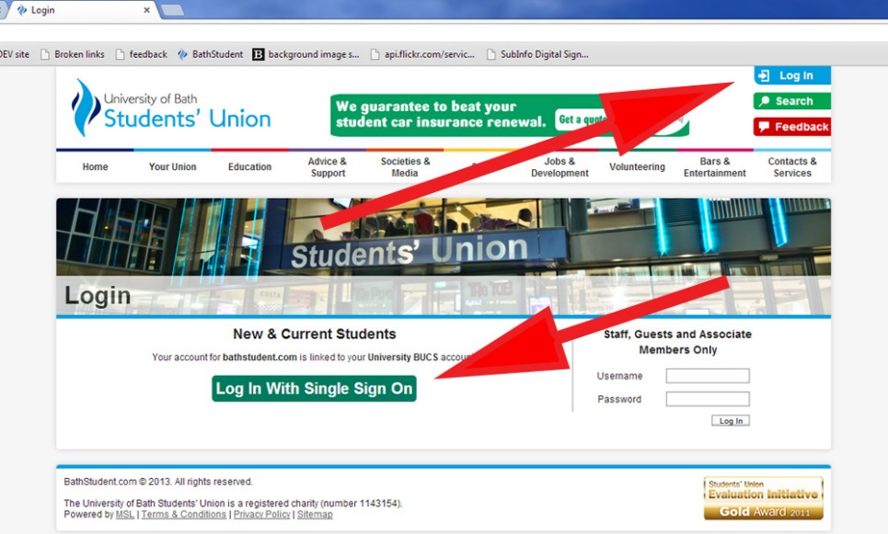
How to Log In
Log in at top right of screen and then use the single sign-on option:

Exec Committee Admin Tools
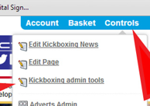
Once logged in, the Admin Tools menu will be the starting
point for many of your website interactions.
1
2
To access them, click Controls at the top right of
screen, then the ‘admin tools’ link.
The most useful 6 are listed below:

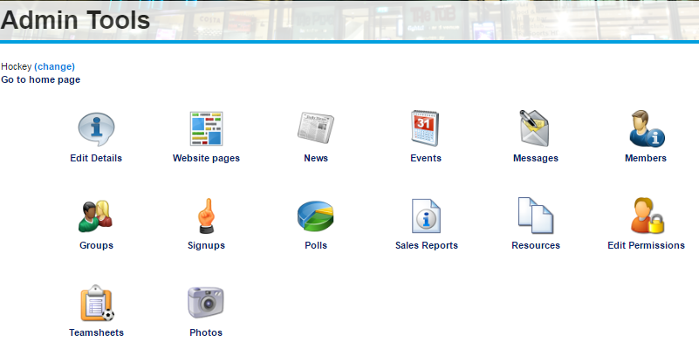
A
B
C
D
E
F
A: Upload your logo and social media details.
B: Create and manage events, that will appear on the bathstudent.com feed and on your /socialsevents page.
C: Send messages on behalf of your society/club.
D: Create and manage Signup lists.
E: Create and manage Teamsheets.
F: Monitor product/ticket sales, and produce a report of any personalisation that was set, eg menu choices.

A: Updating logo and social media details
The logo on your pages needs to be 200 x 200 pixels, and approved by sumarketing@bath.ac.uk. Contact SU Marketing direct for guidelines on your logo.
The approved file needs to be a .jpg. If you aren’t sure how to crop your logo to a square, SU Marketing can assist.
To upload a new logo, press ‘choose file’, select the one you want from the pop-up, click ‘open’, then once the pop-up vanishes, press the blue ‘Update’ button.
To update the big banner image on your pages, send an image with dimensions 750px by 250px to suweb@bath.ac.uk.
Add or update twitter and Facebook info from this screen too.

B: Creating and managing Event listings (and tickets)
Any events you add will appear both on your Events page, and in the BathStudent.com events feed, so if you want to get non-members involved, it is the perfect quick-and-easy way to achieve this.
You can link the event to your product page in order to sell tickets.
This is a very self-explanatory tool, just remember:
- Sport clubs should always tick the ‘sport’ Event Type, and societies the ‘societies’ one, as well as one or more of the options with underscores in.
- Fill in all the information, including and ‘Event name’, ‘Date and time’ and ‘Event type’.
- Put as much information as you can to sell the event in the large box at the bottom. This needn’t just be a description, it can include YouTube videos and links. Full details on how to use the HTML editing tools are in G: Editing all other pages.
- Remember to click ‘save’.

How to set up and sell tickets for your event
This is the best way to collect numbers and menu choices for club/soc meals, and to collect a meal deposit if the venue will require it. Price can be set to £0, if this works best for you.
Speak to your group’s office (eg susa, volunteering) to get ticket sales set up. They will need to know:
- Event Name
- Club/soc
- Description
- Price
- When on sale (date + time)
- When off sale (date + time)
- Where on sale
- Quantity available
- Per person limit [if you only want members to attend, set this to 1, so people can’t buy on behalf of a friend]
- Who can purchase this ticket [would usually be your club/soc members or ‘any current student’ or ‘anyone’, in which case anybody could set up a guest account with BathStudent.com and purchase.]
- Where can ticket be collected (if applicable) [The Bar are happy to set up a collection point for large-scale ticket collections, so if you think this could be appropriate for you, then speak to Mike direct before you submit your ticket request to the Office.]
- Additional receipt text (if any)
- Any customisations (e.g. meal choices)
- Will you want to email ticketholders? [If you will, we can set up a list with the same name as the product, and you can email them. See C: Send Messages… below for more info.]
Info on how to see who has purchased, and any customisations, is in F: Sales Reports

C: Send messages on behalf of your club/soc

Why?
Keep in touch with:
- Current members (list is called ‘Standard Membership’)
- ‘Let me know more’ lists of students’ username-style email addresses you collect*
- Last year’s members to remind them to rejoin (list is called ‘placement elections modifier (do not delete)’)
- Product/ticket purchasers, if you have asked for a list to be set up. We can do this retrospectively, but it’s easiest if it’s done as part of the product/ticket setup.
*If you want a specific mailing list set up, suweb can do this for you. Please give us 2 working days’ notice, to be sure we can fit it in around other SU tasks.

Using a template
You can create and upload your own html email template if you are confident, or use the template which has been developed by the design team responsible for the current SU branding. Press’ Send email’, then scroll down to the ‘Template’ section, and choose what you want from the drop-down. This is a new feature, so we’d be really interested in how you get on with this, as we can develop it further if this will help you to get better use of it. Email suweb@bath.ac.uk with any feedback or requests on this.

Reusing an old email
If you want to reuse an old email as a starting point for a new one, change the filter on Sent items until you can see it, then press the ‘Create a new draft based on this message’ icon:
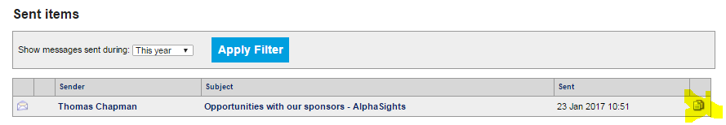

Editing a message
Adding pictures to the email, and working with the formatting, uses the same tools as on the web pages, in G: Editing all other pages.

D: Signups
Annoyingly if you have a lot going on, you can’t split signups by area: all your group’s live signups will appear together, but it’s a great tool even so, if you need to know numbers for something you run regularly, that won’t merit being set up as a ticket.
You can include name, date/time of event and signup period, capacity (including reserves if you want), who has permission to view or sign up, and then a section on what is involved. This has full HTML capability, so you can make it as visually interesting as you like. Use the G: Editing all other pages notes to find out how to add HTML styling.
Once your signup is in place, you can keep an eye on numbers and see who has specifically signed up from the main signup screen:
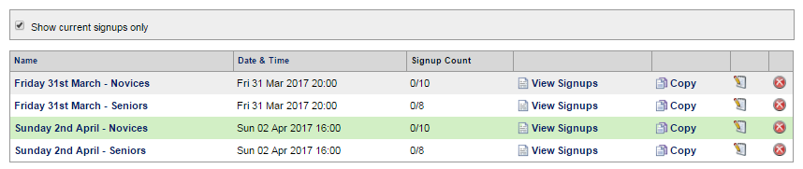
For repeat signups, you can copy an old one and save yourself some work.

E: Teamsheets
Groups who use these provide SUWeb with a list of ‘Captains’ that they wish to access and update teamsheets. Committee members would also be able to set these up.
The dropdown for ‘team’ can be updated by SUWeb if needs be: just drop us an email.
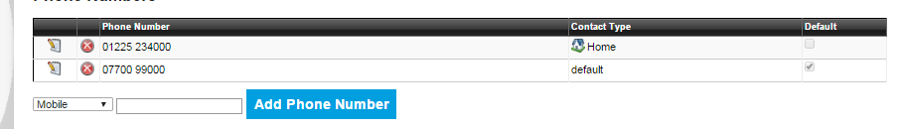
The email and mobile numbers for the captains are taken from each user’s details stored here: https://www.bathstudent.com/contactdetails/ so if a captain’s mobile number is blank when you pick them, ask them to log in to BathStudent.com and use this link to update their record. Whichever they tick as ‘default’ will appear on the teamsheet. To select a different default, they need to press the edit icon, click the ‘default’ checkbox at the right and then press ‘save’.
Here!
For the most up-to-date info on any other aspects of filling out BUCS teamsheets, speak to susa@bath.ac.uk.

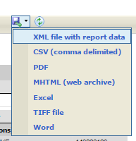
F: Sales Reports
These will show you:
- All the sales of tickets or products for your group
- All the purchasers of a particular ticket or product
- Responses for any customisations on the ticket or product, split by student and providing their name and StudentID.
You can save all these reports into pdf, Excel or Word, using the export button, as shown to the right here.

G: Web Page Editing

Editing your home page
Do NOT use the ‘Edit page’ option in the Controls menu unless you are competent with HTML. Instead, use the little Edit icons dotted about – email suweb@bath.ac.uk if you can’t see them.
To update the big banner image on your pages, send an image with dimensions 750px by 250px to suweb@bath.ac.uk.
When using the Edit icons, you may find that the content editor has limited controls. Click ‘Cancel’ then click the Edit icon again and more controls will appear.

Editing all other pages
Go to the page you want to edit and click ‘Controls’ then ‘Edit page’.
If you see this:
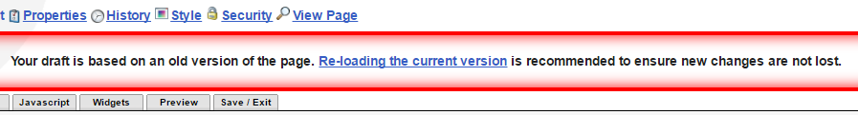
Press ‘re-loading the current version’. We’ve asked MSL to change this, as it’s a pointless feature 99% of the time, but for now this is what we need to do
You should be able to set up most pages to look nice using the WYSIWYG editor, and the following notes describe how to do it. If you want to use CSS or Javascript in your pages, please contact suweb and we will adjust your permissions accordingly.

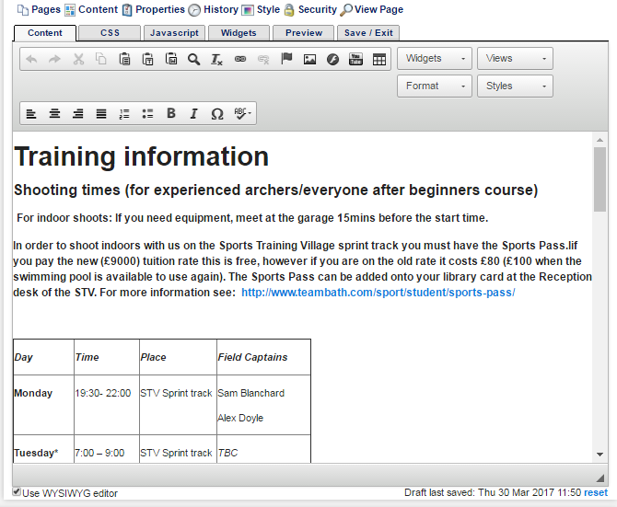
A: To see a visual representation of the page you want to edit, make sure the ‘Use WYSIWYG editor’ box is ticked below the main editing area. If it isn’t ticked you will be editing the HTML code, so only do that if you are confident with the language.
A
B
C
D
E
F
G
I
H
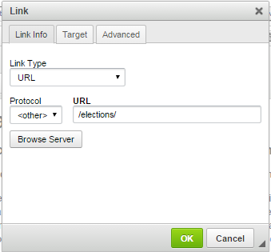
B: Use ‘Format’ to style text as paragraph or a heading 1, 2 or 3. You can then further format paragraphs as lists, insert special characters (eg letters with accents) using the other icon-only menu.
C: To add a link to a different web page, or open a document, highlight the link text and press the infinity symbol. To add a link to another page on BathStudent.com, the URL would be everything after bathstudent.com including all slash symbols, eg /elections/ . To add a link to a document, press ‘browse server’, and choose from previously-uploaded docs or upload something new.
If you want the link to open in a new tab, choose ‘New Window’ from the dropdown on the ‘Target’ tab.

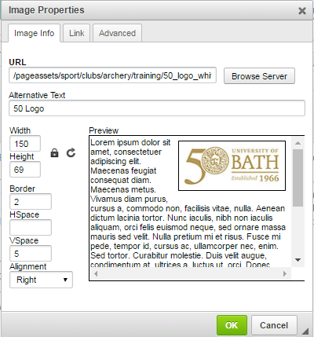
D: You can add images using the ‘image’ icon. To keep with the look of the site, please don’t use ‘clip art’ images and ensure that anything you use is between 200 and 700 pixels wide, so it looks good and loads quickly. Changing the width or height in the popup will make a picture appear at a different size, the whole original image will still be sent to users’ browsers, which will dramatically affect the page load time.
Put your cursor in the place you want your image to appear, and use the ‘image properties’ pop-up to ‘browse server’ to find/upload an image. This auto-populates the ‘URL’ field, so you don’t need to type here.
Use the Preview to decide how you want your image to appear in relation to the text around it. Border will give it a small border, alignment will place it left, right or centred. The ‘HSpace’ increases the space to the left and right of the image. The ‘VSpace’ increases the space above and below the image.
Add ‘alternative text’ so if there’s ever a problem with loading the image, it won’t just show a broken link pic, but will give the user an indication of what they should be seeing.
You can set images as links here too, on the ‘link’ tab. For any BathStudent.com links, you can start typing the link after the ‘bathstudent.com’, eg /elections/ instead of https://www.bathstudent.com/elections/
E: Always host your video on YouTube – let us know if you want to add it to the main BathStudent account. Go to the YouTube video page, click ‘share’ to find the ‘embed code’ or just use the YouTube URL. Setting the display to ‘Make Responsive’ is a good option, in case people are using a mobile.
F: If you want certain content to only show for logged in users, click ‘Views’ and choose ‘members’ to drop in this bit of code:
Then put your member-only content in the ‘content here’ spot.
G: If you need to add special content, eg a signup, product or event list, these are stored under the ‘widgets’ drop-down, and they drop in a bit of text in curly brackets, eg {product}. If the widget you want isn’t in the dropdown, contact suweb@bath.ac.uk and we’ll set it up for you.
H: To publish your page, click the ‘Save / Exit’ tab and then ‘Publish’. If you want to save a version of the page without putting it live, use ‘Save’. This will load next time you visit, but won’t be available for anyone else to edit.
I: To revert to an earlier version of your page, visit the History tab, and click on a different version in the checkbox to make it live. Note that only the HTML saves in the history – if you are using the css or javascript tabs, only the current version of each exists.

External websites
We ask that you use the pages granted to your club or society on BathStudent.com as your only web space (excluding things like social media profiles). There may be a need for external web space if something essential to the running of your club/society cannot be achieved on BathStudent.com, but this must be approved by your SU Officer and by the Marketing and Communications team. Please also be aware that:
- The external web space will need to be hosted by Bath University Computer Services (BUCS)
- Any content that can be hosted on BathStudent.com should not appear on the external web space
The things we would need to know from you are:
- The proposed domain name of the web space
- Why the website is needed for your club or society
- What features do you need that are not available on BathStudent.com
- How you will carry out the handover of responsibility to future committees

Is there anything we’ve missed?
This guide was developed to help you, so if there’s anything you need to know that isn’t covered, get in touch and we will assist: suweb@bath.ac.uk

