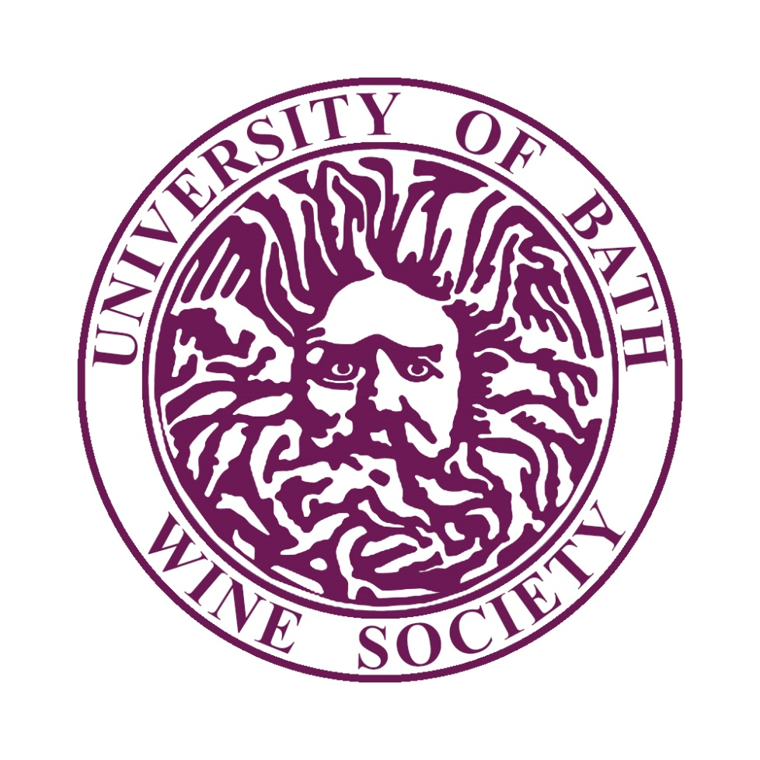

Wine Society
Development Plan 2018-2021
Compiled by Adam George, Chair  Updated by Bas Lodewijks, Chair | 09/05/2018  26/05/2019

Introduction and mission statement

The wine society exists to introduce members to the world of wine. Our industry contacts allow us to facilitate high quality external speakers, who would otherwise be out of reach for a similarly passionate individual. Some of these speakers are members of the Bath alumni and former society members, and indeed some of our members/speakers are current UoB employees. Above all, the wine society strives to be an inclusive and welcoming environment, catered to all ranges of knowledge, in the hope that members can form lasting friendships, launch a career or simply just enjoy the wine and company.

Committee Training
We would recommend booking an appointment with Kim (SU Activities Officer) to go over any committee training, especially finance training.
There is a moodle page called “Students’ Union Societies”. There are a number of useful training documents and relevant forms on there. We recommend you look at the following.
Training | Position | Date completed
Handover Session | All (Core minimum) | 25/05/2019
Finance Training | Chair, Treasurer | TBC
Website Training | Secretary/ Web Officer | TBC
Marketing Information | Secretary (Online) | TBC

Tiers
Please check the tiers framework document on thesubath.com for more details on what each tier entails and the support you receive.
Please tick which tier your society would like to be in for the next academic year.
If you are a new society we recommend you start at Green Tier whilst you are becoming established. Please have a look at the tier system to think about how you could develop your society next year.
Green |  |  | Blue |  |  | Orange | X

If you are selecting Blue or Orange tier, please select which ribbon/s you will be completing and which 3 specific criteria you will be completing for each ribbon.
Blue Tier - pick 1 ribbon to complete over the year.
Orange Tier - pick 2 ribbons to complete over the year.
Sport & Well-being |  |  | Inclusivity | X
Media |  |  | Expansion
Environment & Sustainability |  |  | Academic Development & Employability
Community |  |  | Performance
Campaigning |  |  | Collaboration | X
Ribbon 1: Collaboration
Criteria #: | description
1 | Host an event with a society within your area.
2 | Host an event with a society that is not in your area.
3 | Participate in an event with a society in another university.
Ribbon 2: Inclusivity
Criteria #: | description
1 | Submit application for Inclusivity Award and achieve at least “working towards the Inclusivity Award”.
2 | Work with the relevant student groups to develop a greater understanding of these student areas and how they are likely to participate in your society.
3 | Host events which specifically engage with different groups of students to increase their participation.

Membership
 | 2018/19(based on interest) | 2019/2020 (Forecast) | 2020/21 (Forecast)
Total Annual Membership | 100 | 120 | 130

Membership Target | Aim | How will this be done? | Are any resources required? | Who will do this?
2018/19 | 100 | - Advertising to freshers through all available channels  - Convert casual attenders into members during first few weeks  - A number of introduction events throughout the year aimed at first-time goers  - Develop relationship with stake-holders in Bath to widen appeal  - Reconnect with members from previous year via emails | Marketing resources (banners, flyers, etc.) in the freshers pack. | All committee members will participate.
2019/20 | 120 | - We have attracted slightly more than 100 members last year.  - We will continue this increase by more actively engaging with students, for example during postgraduate activities/induction week | Marketing resources (banners, flyers, etc.) in the freshers pack. | All committee members will participate.
2020/21 | 130

Sponsorship/Funding – not including Students’ Union Budget

The Sponsorship Process
Plans for sponsorship 2017/18
The Society has not yet achieved sponsored status, however it is something we are interested in pursuing. Research has revealed that several other wine societies in the country and sponsored by groups such as Deloitte, who host networking events/drinks. We will continue this avenue of inquiry with the marketing dept.

What will sponsorship be spent on?
Networking events that double up as tastings.

What potential opportunities could be offered to a sponsor?
An opportunity to network with prospective placement seekers, and an enjoyable evening of wine for recruiters.

Fundraising/Community involvement
Raising future funds for the Society
N/A – the society raises all its funds through events, membership fees and budget allowance.

Community involvement plans
The Society maintains ties with venues in Bath such as Amarone, Vignoble and Great Western Wine etc. We plan to maintain these relationships, as well as expand to other potential venues for meals and tastings.

Inclusivity

The Students’ Union promotes an inclusive environment which aims to reach out to and engage with all students. How does the society intend to ensure membership from a diverse range of backgrounds and groups are positively engaged with the society?
We plan to apply to the Inclusivity award, use relevant group contacts (ISA, Enable etc.) within the university, as well as leveraging and inclusive recruitment campaign to ensure students of all backgrounds are welcomed and encouraged to join the society.

